**DAILY ONLINE ACTIVITIES SUMMARY**

|  |  |  |  |  |  |  |  |  |
| --- | --- | --- | --- | --- | --- | --- | --- | --- |
| **Date:** | **9/6/2020** | | | | | **Name:** | **Banish M G** | |
| **Sem & Sec** | **8th Sem** | | | | | **USN:** | **4AL16CS020** | |
| **Online Test Summary** | | | | | | | | |
| **Subject** | | **Big Data Analytics** | | | | | | |
| **Max. Marks** | | **30** | | **Score** | | | **28** | |
| **Certification Course Summary** | | | | | | | | |
| **Course** | **Python for data science** | | | | | | | |
| **Certificate Provider** | | | **Udemy** | | **Duration** | | | **23hrs** |
| **Coding Challenges** | | | | | | | | |
| **Problem Statement:**  Python program to rotate a matrix right by k times  M=3  N=3  matrix=[[12,23,34],[45,56,67],[78,89,91]] | | | | | | | | |
| **Status:COMPLETED** | | | | | | | | |
| **Uploaded the report in Github** | | | | | **yes** | | | |
| **If yes Repository name** | | | | | B**anish_MG** | | | |
| **Uploaded the report in slack** | | | | | **yes** | | | |

Online Test Details: (Attach the snapshot and briefly write the report for the same)

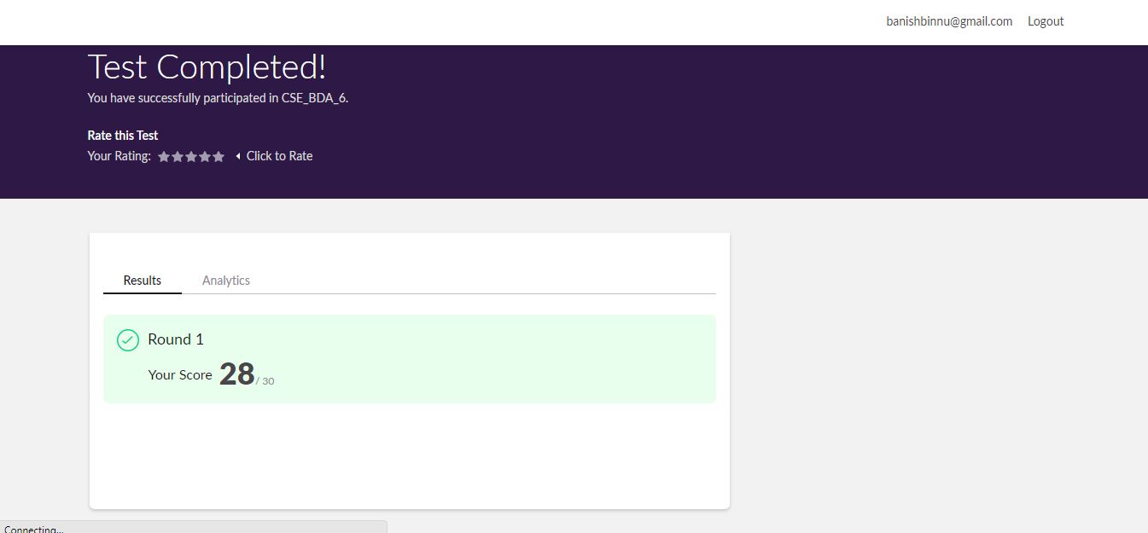

Certification Course Details: (Attach the snapshot and briefly write the report for the same)

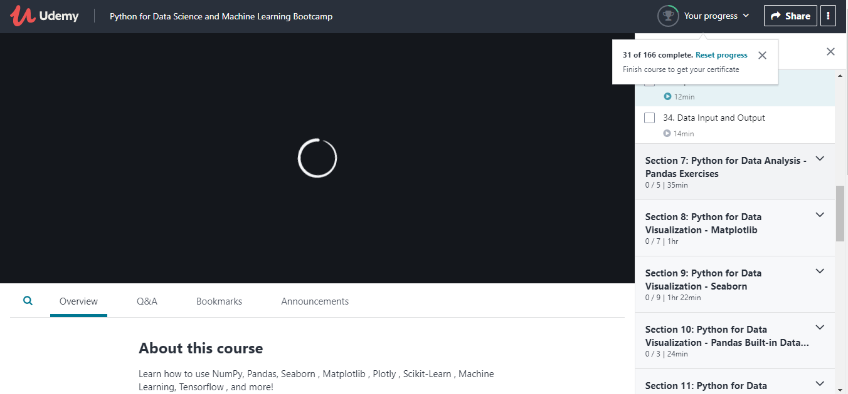

Coding Challenges Details: (Attach the snapshot and briefly write the report for the same)

**Program 1:**

Python program to rotate a matrix right by k times

M=3

N=3

matrix=[[12,23,34],[45,56,67],[78,89,91]]

def rotateMatrix(k):

global M, N, matrix

temp=[0]*M

k=k%M

for i in range(0,N):

for t in range(0,M-k):

temp[t]=matrix[i][t]

for j in range(M-k,M):

matrix[i][j-M+k]=matrix[i][j]

for j in range(k,M):

matrix[i][j]=temp[j-k]

def displayMatrix():

global M, N, matrix

for i in range(0,N):

for j in range(0,M):

print("{}".format(matrix[i][j]),end="")

print()

k=2

rotateMatrix(k)

displayMatrix()